Overview
This document discusses ways of interacting with and retrieving data from a Sajara instance. It outlines the basics of how a Sajara system stores some of its data, as well as the technical details behind how to get access to the data through public-facing APIs.

The Sajara API’s are currently intended to support read-only search operations against the Sajara database. There are three basic scenarios that the API’s are attempting to support, and each of these scenarios results in a different output data structure:
- Monitor the database for changes – The RSS data structure returns a title, description, location (via GeoRSS) and photo thumbnail.
- Display Search Results on a Map – While the GeoRSS format will also support this, the KML standard is a more commonly supported data structure and provides a great deal of flexibility in terms of styling and content.
- Display Search Results – The database returns either an image or JSON objects for incorporation into an HTML-based display.

Basic Object Relationship
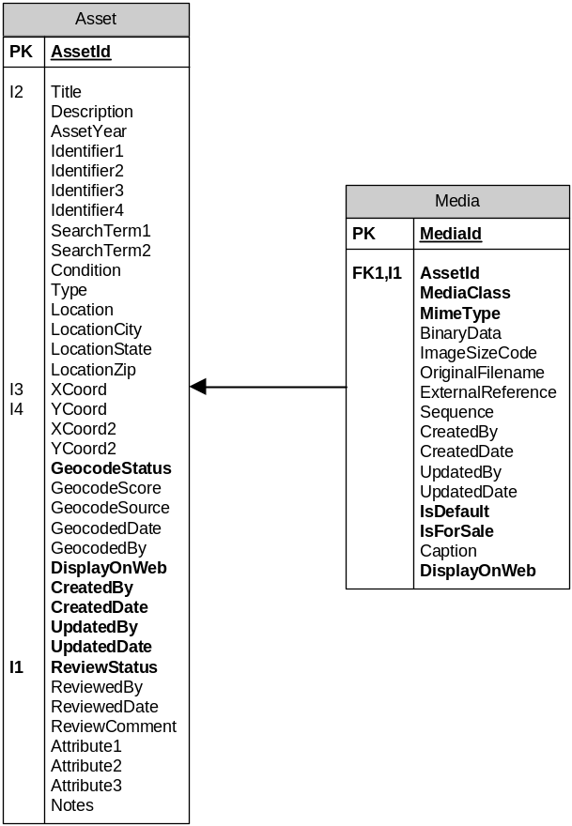The two major data objects in the Sajara system are Assets and Media. Assets are the basic unit of currency in the system: every real-world object in the system is represented as an Asset, and the Asset object contains all of the relevant information to that object. Media represent instances of objects that further describe the Asset, such as photos or documents pertaining to the Asset. Media can have their own data about them (such as the photo’s photographer, or a caption describing the photo). Below is an overview of these two object types and some of the properties of each:

Accessing the Asset Database Using the Sajara API
Sajara exposes several interfaces for querying data. Below is a list of those interfaces.

Custom Search Links
The simplest of these is a query string protocol that can be passed to the search page, to link directly to the Sajara search page (Search.aspx) with certain search parameters. The search parameters are as follows:

Geographic Search Parameters:
Search Type | Parameter(s) | Description | Type | Range
type=address | address | Center search at a specific address | Text | Any valid address
type=neighborhood | neighborhood | The name of one of the neighborhoods or areas defined in the Sajara implementation | Text | A neighborhood or area name
type=area | minx,miny,maxx,maxy | Give a specific area on which to focus the search.  The extent will be used to focus to the nearest zoom level; a point-based search is used when minx=maxx and miny=maxy. | Number | Any set of numbers that defines an extent in the implementation coordinate system.

Other Search Parameters:
Parameter(s) | Description | Type | Range | Default
keywords | Search for Assets whose title, description, or notes fields, or related people or topics contain the keywords. | Text | Any text string to be searched for. | None
topics | Sometimes also known as Tags. Search for Assets that have had specific identifiers associated with them. | Text | Comma-separated list of Topic or Tag names defined in the system. | None
fromDate, toDate | Search for Assets whose creation date is before or after a specific year. These can be used independently or in conjunction. | Number | Any year. | None
collections | Limit the search to specific collection(s). | Text | Comma-separated list of Collection names. | None
withoutMedia | Include results that do not have digitized media. | True/False | ‘true’ or ‘false’ | false
withoutLocation | Include results that do not have an associated location. | True/False | ‘true’ or ‘false’ | false
updateDays | Only show records that have been updated in this many days. 0 means updated any time. | Number | 0, 1, 3, 5, 7, 10, 30, 60, 90, 180, or 365 | 0
sortOrderP | Criteria for ordering Assets. | Text | ‘Distance’: Distance from the center point of the search extents.  ‘CircaDesc’: From latest Asset date to earliest.  ‘CircaAsc’: From earliest Asset date to latest.  UpdatedDateDesc: From most to least recently updated. | Distance
start | Which Asset to retrieve first. | Number | 0 or any multiple of the limit parameter (see below). | 0
limit | How many Assets to retrieve. | Number | 12, 16, 20, 24 | 12

Examples (using the Muralfarm.org Sajara instance):

Neighborhood Search | http://www.muralfarm.org/MuralFarm/Search.aspx?type=neighborhood&neighborhood=Angora
Keyword Search | http://www.muralfarm.org/MuralFarm/Search.aspx?keywords=labor
Recently Updated | http://www.muralfarm.org/MuralFarm/Search.aspx?updateDays=10

GeoRSS Link
In addition to the ability to link to a search page with a given set of criteria, it is also possible to retrieve the Assets resulting from a search as an XML document, via a GeoRSS search. The GeoRSS call uses the same set of parameters as the search page.

Examples (using the Muralfarm.org instance):

Neighborhood Search | http://www.muralfarm.org/MuralFarm/RssFeed.ashx?type=neighborhood&neighborhood=Angora
Keyword Search | http://www.muralfarm.org/MuralFarm/RssFeed.ashx?keywords=labor
Recently Updated | http://www.muralfarm.org/MuralFarm/RssFeed.ashx?updateDays=10

The output of the document from the GeoRSS link includes basic information about each Asset returned, including:
- Title
- Description to be shown in the RSS
- Link to the Asset details
- The date of RSS Publication
- The Asset’s location
These items can be parsed by a standard XML parser and, specifically, the Asset identifier can be parsed from the detail link URL.

Single Asset Information as KML
Similarly to the GeoRSS link, Sajara has the ability to return KML information for a single Asset, which can be parsed to find individual details. The link format for retrieving KML data for a single Asset is (example using the Muralfarm.org instance):

http://www.muralfarm.org/MuralFarm/Kml.ashx?assetId=?

with the value for assetId being an Asset identifier, as retrieved from a GeoRSS query.

The response to this query is a KML document, which includes (under kml/Document/Folder/Placemark/description) an HTML snippet that can be used to describe the Asset, as well as the Media IDs for all of the screen-resolution images associated with that Asset.

Single Asset Information as JSON
Asset details can also be returned as JSON based on an Asset ID. However, this specification changes over time. If it is necessary for a particular implementation, please contact Avencia for a current specification.

Image Handler
Sajara provides a handler that allows access to the Media data in the system. It is called MediaStream.ashx and works under two scenarios: retrieving a particular Media object’s binary information, or retrieving a Media object associated with an Asset. When retrieving a particular Media object’s binary data, this handler takes only one parameter, mediaId. When retrieving binary data associated with an Asset, this handler takes the following parameters:

Parameter(s) | Description | Type | Range
assetId | The asset whose media you are requesting. | Number | Any valid Asset Id
SC | The size code for the default media object. | Number | 1 = 100px wide image  2 = 600px wide image

Using the Asset Id approach is not recommended for retrieving Media images from Asset object with more than one associated Media object. For Assets with multiple associated Media objects, this handler will return the binary from the first Media object returned from the database. This may or may not be the default Media object for this Asset.

The response from either scenario is the binary information associated with the Media object with that id, and in the case of images, is returned in JPEG format.

Accessing the Featured Assets

Featured Assets, Areas, People and Tags
In addition to searching the Sajara database and returning results as KML, RSS and JSON, a separate API is provided for returning a set of featured assets, neighborhoods, tags (themes or categories) and people. These featured records are not activated in every Sajara implementation and have to configured and maintained by database managers or administrators.

Similar to search results, Sajara provides a JSON-based handler for querying the details of feature items, FeatureHandler.ashx. The handler requires a POST request, and the request parameters are:
Parameter(s) | Description | Type | Range
start | Which start feature to request. | Number | 0…Number of Features in System
limit | How many features to request. | Number | 0…(Number of Features in System – start)
FeatureType | What kind of features you are looking for. | Text | Asset, Person, Theme, or Neighborhood

The response is a JSON object, with the following format:
{
totalCount: the total number of Features with the requested type in the system
mediaList: [
assetId: the Asset’s ID
caption: the caption for the shared Media item
desc: the description assigned to the Feature
mediaId: the ID of the shared Media item
]
}

